Install a DNS server in Windows Server 2008
By Steven Warren, Special to ZDNet Asia
Tuesday, April 22, 2008 02:50 PM
IT administrators who have little or no experience with Domain Name System (DNS), can learn to install, configure and troubleshoot a Windows Server 2008 DNS server.
As many of you are probably aware, the Domain Name System (DNS) is now the name resolution system of choice in Windows. Without it, computers would have a very tough time communicating with each other.
However, most Windows administrators still rely on the Windows Internet Name Service (WINS) for name resolution on local area networks and some have little or no experience with DNS. If you fall into this category, read on. We'll explain how to install, configure, and troubleshoot a Windows Server 2008 DNS server.
Installation
You can install a DNS server from the Control Panel or when promoting a member server to a domain controller (DC) (Figure A).
During the promotion, if a DNS server is not found, you will have the option of installing it.
Figure A
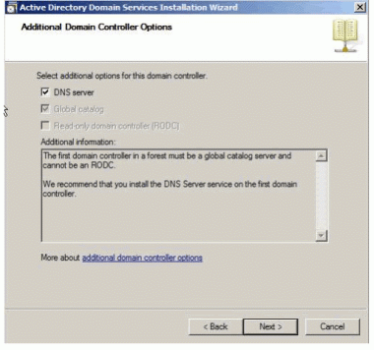
Domain controller
To install a DNS server from the Control Panel, follow these steps:
- From the Start menu, select | Control Panel | Administrative Tools | Server Manager.
- Expand and click Roles (Figure B).
- Choose Add Roles and follow the wizard by selecting the DNS role (Figure C).
- Click Install to install DNS in Windows Server 2008 (Figure D).
Figure B
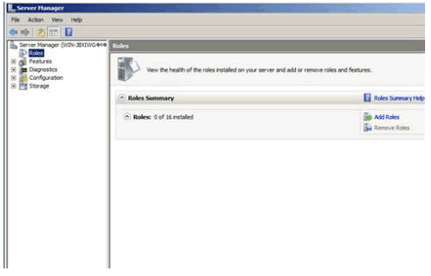
Expand and click Roles
Figure C
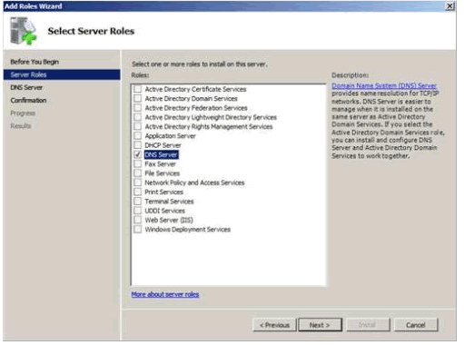
DNS role
Figure D
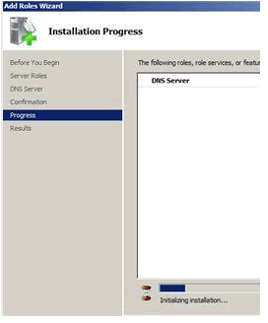
Install DNS
DNS console and configuration
After installing DNS, you can find the DNS console from Start | All Programs | Administrative Tools | DNS. Windows 2008 provides a wizard to help configure DNS.
When configuring your DNS server, you must be familiar with the following concepts:
- Forward lookup zone
- Reverse lookup zone
- Zone types
A forward lookup zone is simply a way to resolve host names to IP addresses. A reverse lookup zone allows a DNS server to discover the DNS name of the host. Basically, it is the exact opposite of a forward lookup zone. A reverse lookup zone is not required, but it is easy to configure and will allow for your Windows Server 2008 Server to have full DNS functionality.
When selecting a DNS zone type, you have the following options: Active Directory (AD) Integrated, Standard Primary, and Standard Secondary. AD Integrated stores the database information in AD and allows for secure updates to the database file. This option will appear only if AD is configured. If it is configured and you select this option, AD will store and replicate your zone files.
A Standard Primary zone stores the database in a text file. This text file can be shared with other DNS servers that store their information in a text file. Finally, a Standard Secondary zone simply creates a copy of the existing database from another DNS server. This is primarily used for load balancing.
To open the DNS server configuration tool:
- Select DNS from the Administrative Tools folder to open the DNS console.
- Highlight your computer name and choose Action | Configure a DNS Server' to launch the Configure DNS Server Wizard.
- Click Next and choose to configure the following: forward lookup zone, forward and reverse lookup zone, root hints only (Figure E).
- Click Next and then click Yes to create a forward lookup zone (Figure F).
- Select the appropriate radio button to install the desired Zone Type (Figure G).
- Click Next and type the name of the zone you are creating.
- Click Next and then click Yes to create a reverse lookup zone.
- Repeat Step 5.
- Choose whether you want an IPv4 or IPv6 Reverse Lookup Zone (Figure H).
- Click Next and enter the information to identify the reverse lookup zone (Figure I).
- You can choose to create a new file or use an existing DNS file (Figure J).
- On the Dynamic Update window, specify how DNS accepts secure, nonsecure, or no dynamic updates.
- If you need to apply a DNS forwarder, you can apply it on the Forwarders window. (Figure K).
- Click Finish (Figure L).
Figure E
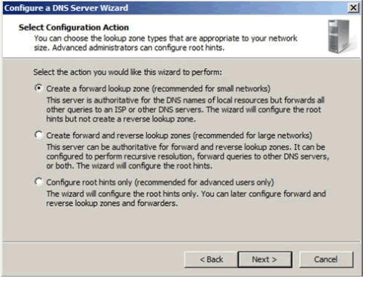
Configure
Figure F
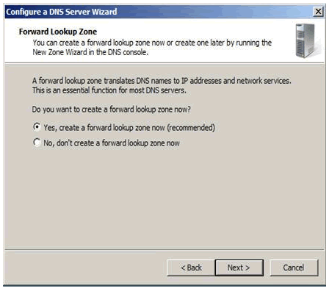
Forward lookup zone
Figure G
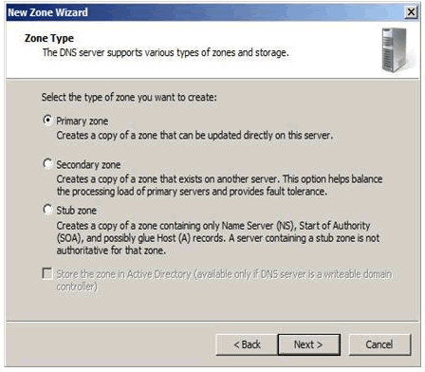
Desired zone
Figure H
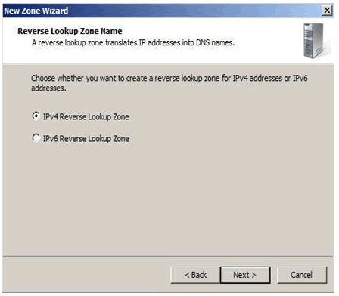
IPv4 or IPv6
Figure I
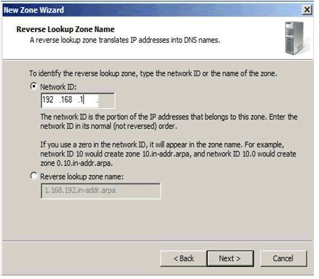
Reverse lookup zone
Figure J
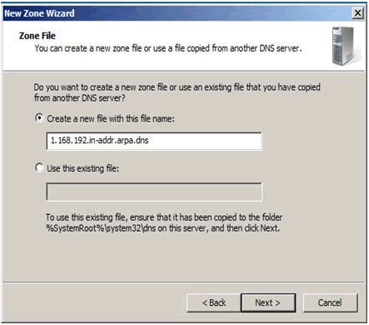
Choose new or existing DNS file
Figure K
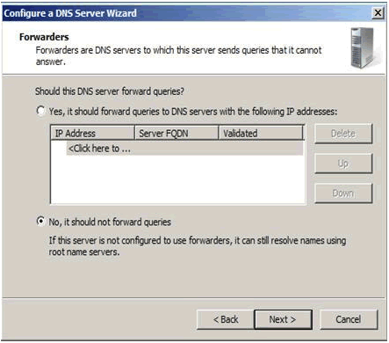
Forwarders window
Figure L
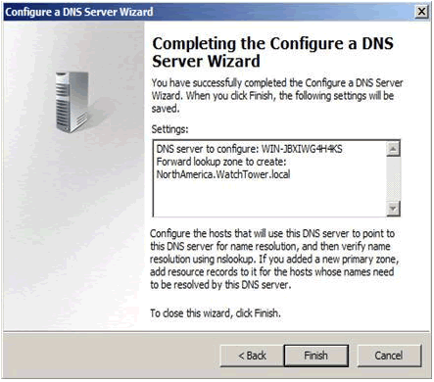
Finish
Managing DNS records
You have now installed and configured your first DNS server, and you're ready to add records to the zone(s) you created. There are various types of DNS records available. Many of them you will never use. We'll be looking at these commonly used DNS records:
- Start of Authority (SOA)
- Name Servers
- Host (A)
- Pointer (PTR)
- Canonical Name (CNAME) or Alias
- Mail Exchange (MX)
Name Servers
Name Servers specify all name servers for a particular domain. You set up all primary and secondary name servers through this record.
To create a Name Server, follow these steps:
- Select DNS from the Administrative Tools folder to open the DNS console.
- Expand the Forward Lookup Zone.
- Right-click on the appropriate domain and choose Properties (Figure N).
- Select the Name Servers tab and click Add.
- Enter the appropriate FQDN Server name and IP address of the DNS server you want to add.
Figure N
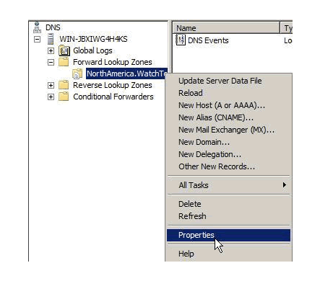
Name Server
Host (A) records
A Host (A) record maps a host name to an IP address. These records help you easily identify another server in a forward lookup zone. Host records improve query performance in multiple-zone environments, and you can also create a Pointer (PTR) record at the same time. A PTR record resolves an IP address to a host name.
To create a Host record:
- Select DNS from the Administrative Tools folder to open the DNS console.
- Expand the Forward Lookup Zone and click on the folder representing your domain.
- From the Action menu, select New Host.
- Enter the Name and IP Address of the host you are creating (Figure O).
- Select the Create Associated Pointer (PTR) Record check box if you want to create the PTR record at the same time. Otherwise, you can create it later.
- Click the Add Host button.
Figure O
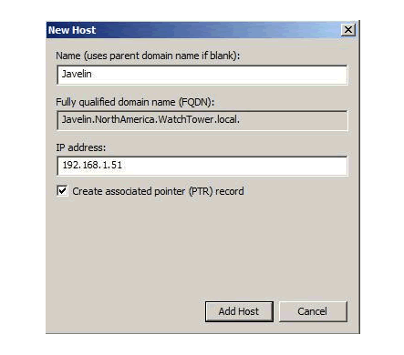
A Host (A) record
AAAA Host is similar with “Figure O”。
The only different is the IP address：A Host (A) record is IPv4，and AAAA Host (AAAAA) record is IPv6 address。
Test：
Nslookup utility
For A Host (A) record:
Run the cmd“nslookup dc03.zyxel.cn” in the Client, where “dc03.zyxel.cn” is the domain name which you want to parse.
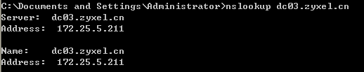

For AAAA Host (AAAAA) record:


